
What's the Weather?
The graph compares the amount of rain in Chittagong (Bangladesh) and London (UK) during 2005.
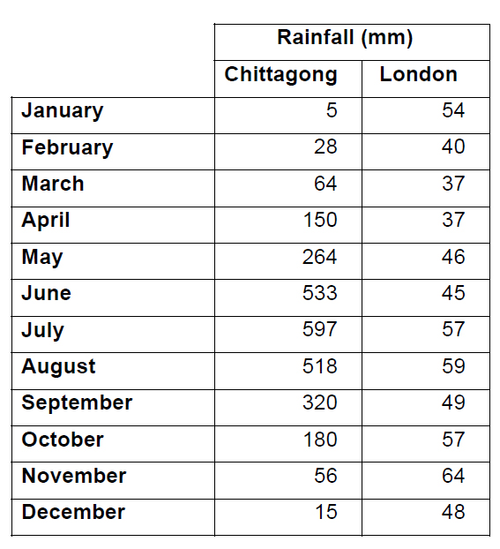
(Replicate the above chart in Microsoft Excel – Add colour and borders.)
- Draw a graph to compare the rainfall in Chittagong and London. Think first – should it be a line graph or a bar graph?

- a - Which month has the highest rainfall in London? b – Which month has the highest rainfall in Chittagong?

- When are floods likely to happen in Chittagong? How would floods affect the people living in Chittagong?

- Bangladesh is not a rich country. They do not have large reservoirs to store water. Are there any times of the year when there could be water shortages in Chittagong

- In which month does London get more rain than Chittagong? Show this in a pie chart.

